Epsilon Delta definition

Def

On the left hand of limit.

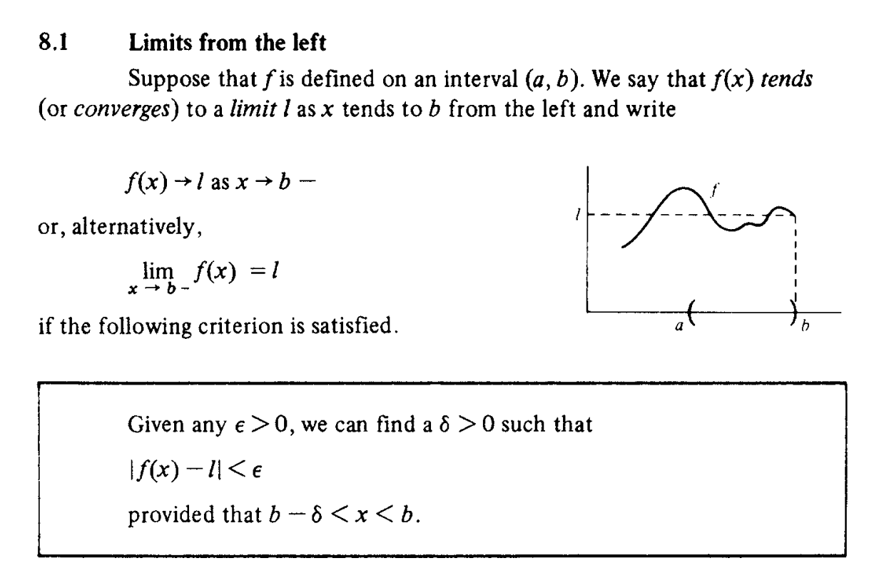

On the right hand of limit.

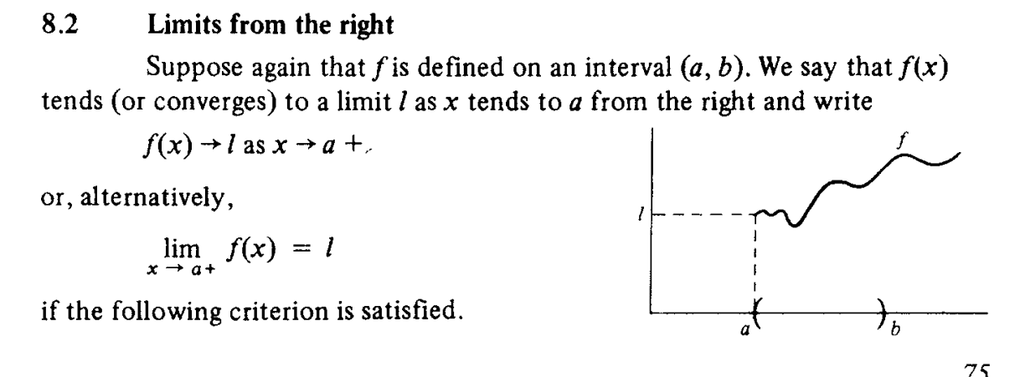

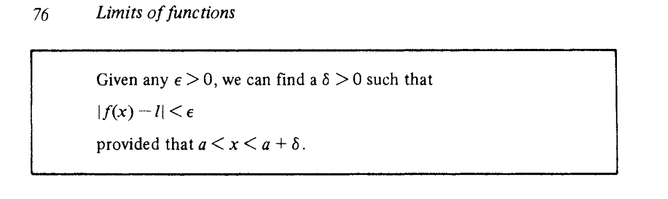

On the both hand of limit.

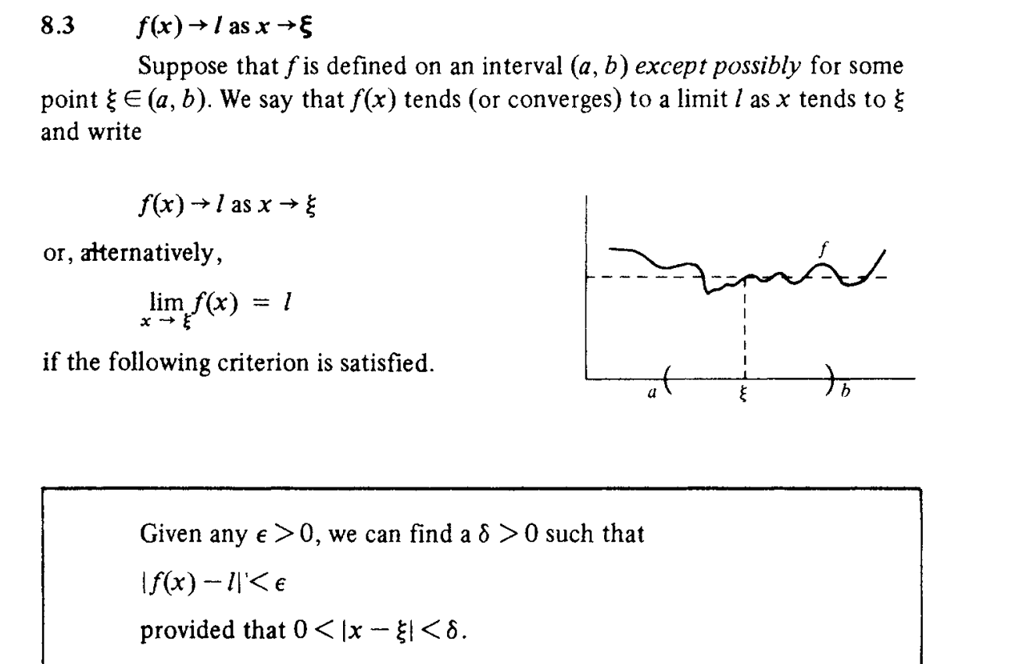

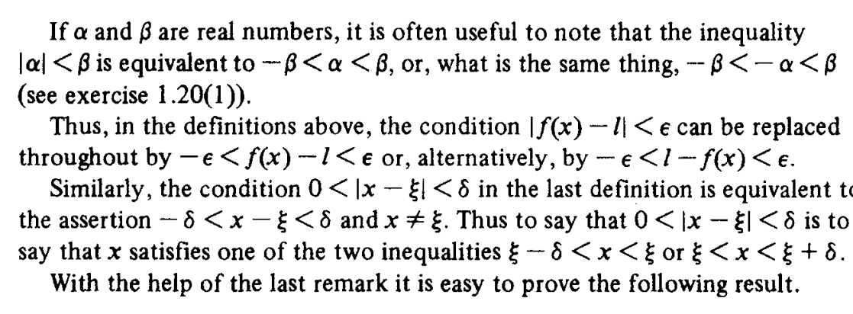

To explain it, it is very easy.

Recall:

On the left hand of limit, the criteria must holds.



On the right hand of limit, the criteria must holds.



On the both hand of limit, consider two cases.

Case 1:

First, look from left of limit.

$$−delta<x−b<0$$

Case 2:

Finally, look from right of limt.

$$0<x−a<delta$$

Let $$c=a=b$$. Then combining two equations, it will be

$$−delta<x−c<delta$$

=> $$\left|x−c\right|<delta$$

Statement

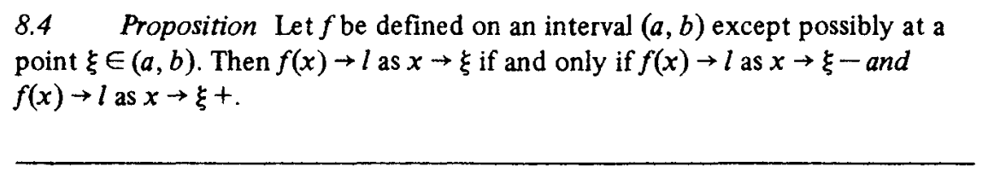

Proof

See the explanation at above section.

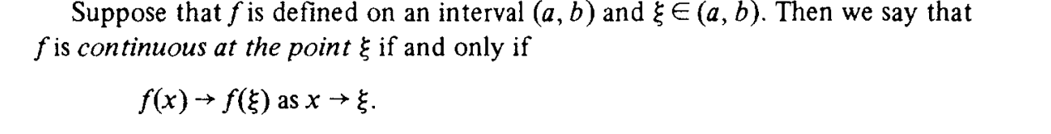

Proof

See the above proof in this section and the example in section 8.5 page 77 in the cookbook.

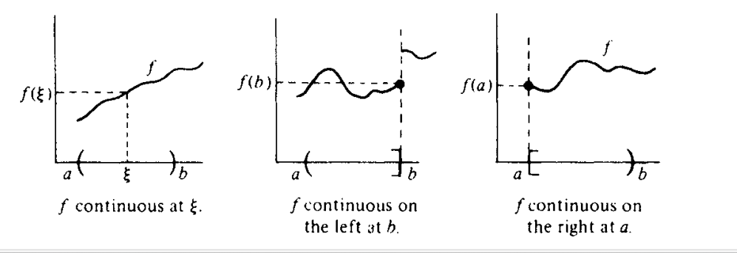

Other statement

Continuous for linear function

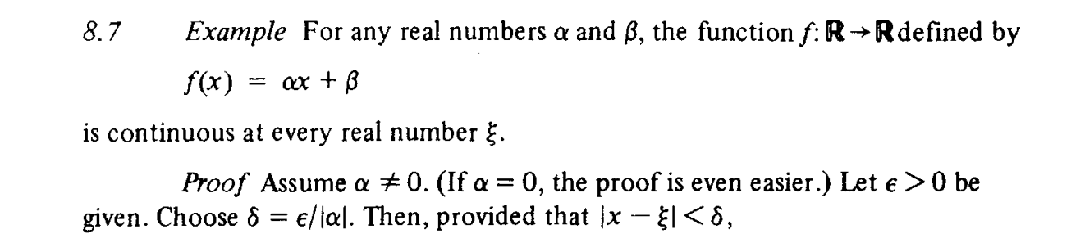

Proof

Method 1:

Case 1: $$alpha==0$$

If $$alpha==0$$, then the formula will be

$$f\left(x\right)=beta$$

The three requirements of a continuous function both satisfies:

$$\lim\left(x→a^{−},f\left(x\right)\right)$$ = $$beta$$

$$\lim\left(x→a^{+},f\left(x\right)\right)$$ = $$beta$$

It is true.

Case 2: $$alpha != 0$$

See the proof in section 8.7 page 78 in the cookbook.

Method 2:

Apply the statement about connexion with convergence sequence.

Used in example section 8.8 page 80 in the cookbook.

See the proof in section 8.11 page 80 in the cookbook.

Method 3:

See the section 10.6 page 96 in the cookbook.

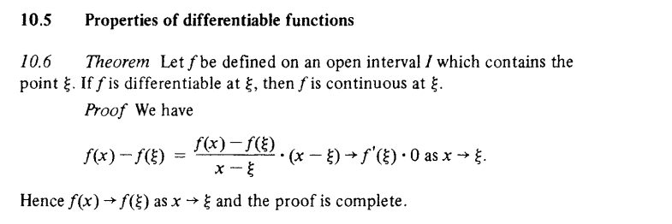

Connexion with convergence sequences

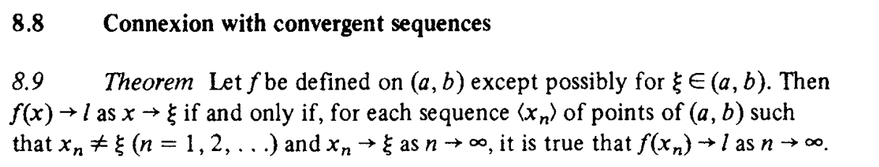

Proof

See the proof in section 8.8 page 79 in the cookbook.

Continuous for polynomial function

Proposition

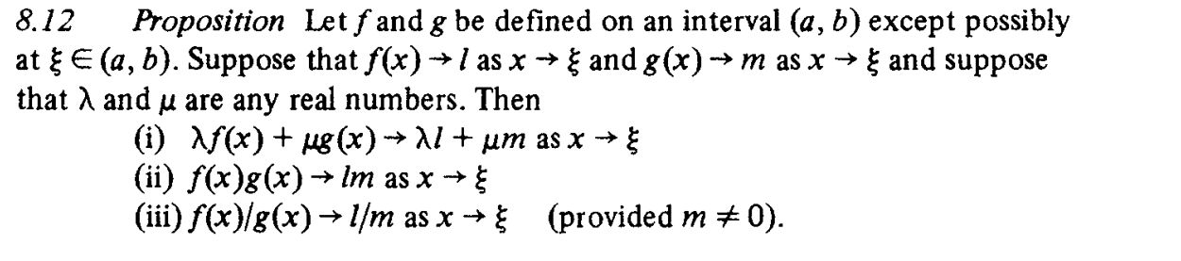

Theorem



Proof

Theorem

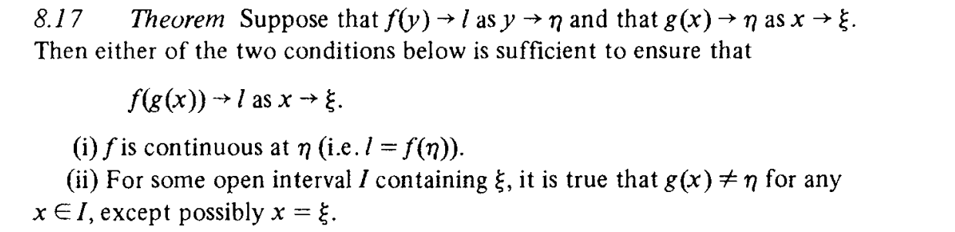

Proof

See section 8.17 page 82 in the cookbook.

Ref

Download the free PDF at zlib.pub.

[Download Mathematical analysis: a straightforward approach by Binmore, K. G (zlib.pub)](https://zlib.pub/book/mathematical-analysis-a-straightforward-approach-27hjslaf53bg)